Jawaban Soal UTS-1 Farmakokinetika:
Sabtu, 19 Oktober 2024; pk 09.00-10.40 wib
Prof. Dr. Apt, Ros Sumarny, M.S
================================================================

B. Soal 2 (dua) kompartemen intravena

Pasien A memperoleh intravena antibiotika 50 mg melalui intravena bolus.
Dari data cuplikan kadar obat dalam darah (mg/L) terhadap waktu (jam) persamaan sbb:

Cp (t) =187,42 $e^{−1,73. t}$ + 12,51 $e^{−0,12.t}$

Tugas.
- Hitunglah nilai K₁₂, K₂₁, K el, T ½ eliminasi , T ½ distribusi, AUC, Cl, Vd sentral, Vd perifer, Vd ss (steady state).
- Berapa lama obat tersebut bekerja bila diketahui KHM= 4.00 mg/L

==================================================================
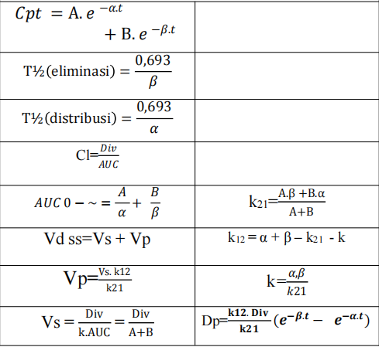

Jawaban
No | Parameter | Hasil | Satuan | Score
1 | T½ distribusi | 0,40 | Jam | 2,5
2 | T½ eliminasi | 5,77 | Jam | 2,5
3 | K₁₂ | 0,6887 | Jam⁻¹ | 5,0
4 | K₂₁ | 0,2207 | Jam⁻¹ | 5,0
5 | K eliminasi | 0,9406 | Jam⁻¹ | 5,0
6 | AUC _{0-~} | 212,585 | mg.jam/L | 5,0
7 | Cl | 0,2352 | L/Jam | 5,0
8 | Vd sentral | 0,2501 | L | 5,0
9 | Vd perifer | 0,7801 | L | 5,0
10 | Vd steady state | 1,0302 | L | 5,0
11 | T =?? KHM= 4,0 mg/L | 9,5 | Jam | 5,0

